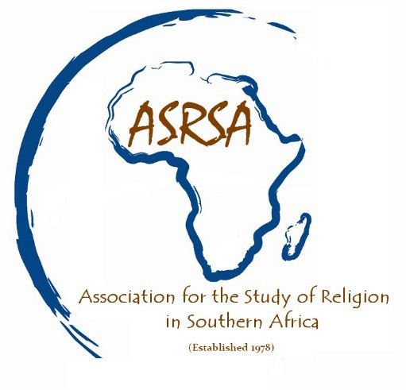
ASSOCIATION FOR THE STUDY OF RELIGION IN SOUTHERN AFRICA

University of South Africa,
Department of Religious Studies & Arabic
Venue: Unisa’s Muckleneuk Campus, Pretoria
4th – 5th September 2019

CONFERENCE INFORMATION

Welcome to the 41st Annual Congress of the Association for the Study of Religion in Southern Africa

We have put together some important information to assist you with registration for the meeting and to prepare for your travel

REGISTRATION COSTS
Type of Registration | Cost
ASR(SA) Membership Fees per annum | R 150 per annum
Normal Registration by 31 July 2019 | R 1 000 (R500 per day)  Participants from outside South Africa will be allowed to pay their registration fee on the 4th of September to alleviate bank charges.
Student Rate by 31 July 2019 | R 400 (R200 per day)

Payment Methods
Payments to be made into the following account:
Name of Account: Association for the Study of Religion in Southern Africa
Bank: Standard Bank
Account No.: 01 309 290 1
Type of Account: Current Account
Branch: Musgrave
Branch Code: 04 2626
Reference: Surname & 2019

One you have registered, you will receive an invoice (that will include registration fees and 2019 membership fees).

If you do not receive one, please write to the Treasurer Beverly Vencatsamy (asrsagroup@gmail.com / vencatsamyb@ukzn.ac.za).

We look forward to your participation in Pretoria.
Please write to us on the ASRSA email if you have any queries.
ACCOMMODATION
Recommended accommodation
Rates negotiated with these recommended guest houses are inclusive of breakfast. Please indicate that you will be a participant at the ASRSA Conference when you make a reservation at these guest houses.

Brooklyn Guesthouses
info@brooklynguesthouses.co.za
132 Murray street, Brooklyn, Pretoria
Tel: +27 12 362 1728
Ronel Nel Mobile: +27 84 252 4626
Budget single @ R650 | Budget double @ R790
Standard single @ R730 | Standard double @ R900
Deluxe single @ R790|Deluxe double or twin @ R990

Muckleneuk Guest House
info@muckleneukguesthouse.co.za
228 Cilliers Street, Muckleneuk, Pretoria
Tel: 012 341 8059
Mobile: + 27 (0) 76 733 7473 Suzette du Plessis / Colin Brazendale
Four rooms at a special rate of R650.00 for single occupancy, R850 for a twin room for 2 people sharing. The other rooms will be R750 (single person) and R950 (2 people sharing).

Muckleneuk Manor
muckleneukmanor@gmail.com
270 Mears Street,Muckleneuk, Pretoria
Tel: +27 60 907 0050
Mobile: +27 82 795 041
R680.00 per person, single occupation and R980.00 for double occupation.

Treetops and Treats
info@treetopsandtreats.co.za
611 Leyds Street, Muckleneuk, Pretoria
Tel: 012 343 8619
Mobile: 072 269 8982 Selvie Subbiah
R680.00 per person per night for 3 nights.

You may also wish to search for other possibilities in the Muckleneuk area in Pretoria at
https://www.safarinow.com/destinations/muckleneuk/hub.aspx and at www.booking.com

Post-conference tour on Friday 6 September
Please email your interests to Prof Michel Clasquin-Johnson at clasqm@unisa.ac.za. Depending on interests expressed, Michel will arrange a post-conference tour for Friday 6 September.

